

|  |
| --- |
| REPORT OF THE CELEBRATION OF CONSTITUTION DAY -2021 |
|  |
| 26 NOVEMber 2021  VIDYAVARDHAKA LAW COLLEGE  Report by: Dr. K.L.CHANDRASHEKHARA |

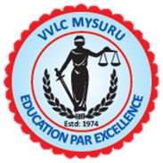

REPORT OF THE CELEBRATION OF CONSTITUTION DAY -2021

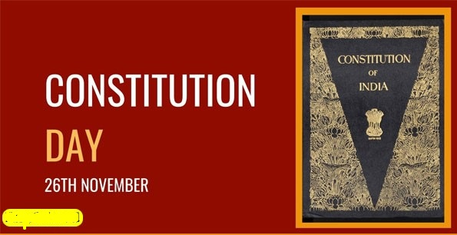

Constitution Day (or Samvidhan Divas), also known as National Law Day, is celebrated in India on 26 November every year to commemorate the adoption of the Constitution of India. On 26 November 1949, the Constituent Assembly of India adopted the Constitution of India, and it came into effect on 26 January 1950.

The Government of India declared 26 November as Constitution Day on 19 November 2015 by a gazette notification. The Prime Minister of India made the declaration on 11 October 2015 while laying the foundation stone of the B. R. Ambedkar's Statue of Equality memorial in Mumbai. The year of 2015 was the 125th birth anniversary of Ambedkar, who had chaired the drafting committee of the Constituent Assembly and played a pivotal role in the drafting of the constitution. Previously this day was celebrated as Law Day. 26 November was chosen to spread the importance of the constitution and to spread thoughts and ideas of Ambedkar.

On account of this incredible and significant day Vidyavardhaka Law College, Mysuru organised CONSTITUTION DAY on 26th November 2021.

Sri Hosamani Pundalik, District & Sessions Judge, Mysuru delivered his keynote lecture on the Historical and Contemporary Importance of Indian Constitution. Er. P. Vishwanath, Hon’ble Secretary, Vidyavardhaka Sangha ®, Mysuru and Sri Shrishaila Ramannavar, Hon’ble Treasurer, Vidyavardhaka Sangha ®, Mysuru participated as a Distinguished Guest of Honour of the Constitution Day. Dr. P.Deepu, Principal, Vidyavardhaka Law College, welcomed the guest and all the participants. Sri Gundappa Gowda, Hon’ble President, Vidyavardhaka Sangha ®, Mysuru, will be presided over the programme. Prof. K.B. Vasudeva, Director Legal Studies, VVLC, Teaching & Non-teaching staff and Students were actively participated in the programme.

|  |
| --- |
| *Sri Hosamani Pundalik, District & Sessions Judge, Mysuru and other dignitaries of the programme inaugurating the Constitution Day by lighting the lamp.* |

The key opinions and important insights from Sri Hosamani Pundalik lecture is mentioned below:

*“26 November has its own importance in the history of independent India because on this day in 1949, the Constitution of India was adopted and it came into effect on 26 January, 1950. Therefore, marking the dawn of a new era. To acknowledge the contribution of the framers of the Constitution and to aggravate the people regarding the prominent values, 26 November is celebrated as the ‘Constitution Day’.*

*As we know that on 15 August 1947, India became independent, and on 26 January 1950, we celebrate Republic Day because on this day the Constitution of India came into effect.*

*In 1934, the demand of the Constituent Assembly was made. Let us tell you that M.N. Roy, a communist party leader, was the first who mooted the idea. It was taken up by the Congress party and finally, in 1940, the demand was accepted by the British government. Indians are allowed to draft the Indian Constitution in the August offer.*

*On 9 December 1946, the Constituent Assembly for the first time met before independence. The first president of the Constituent Assembly was Dr. Sachchidananda Sinha. On 29 August 1947, a Drafting Committee was constituted to prepare a Draft Constitution with Dr. B.R. Ambedkar as a Chairman. On 26 November, 1949, the Committee had finished their work. On 24 January 1950, the process was completed when the members signed two handwritten copies of the document one each in Hindi and English.*

*The first meeting of the Assembly was in New Delhi on 9 December 1946 and last till 24 January, 1950. During this time total of 11 sessions were held and met for around 166 days. This is the period between the adoption and enforcement when thorough reading and translation from English to Hindi was done.*

*On 26 January, 1950, the Constitution of India came into force and became the law of the land.”*

*Students of Vidyavardhaka Law College taking oath of the preamble of the Indian Constitution*

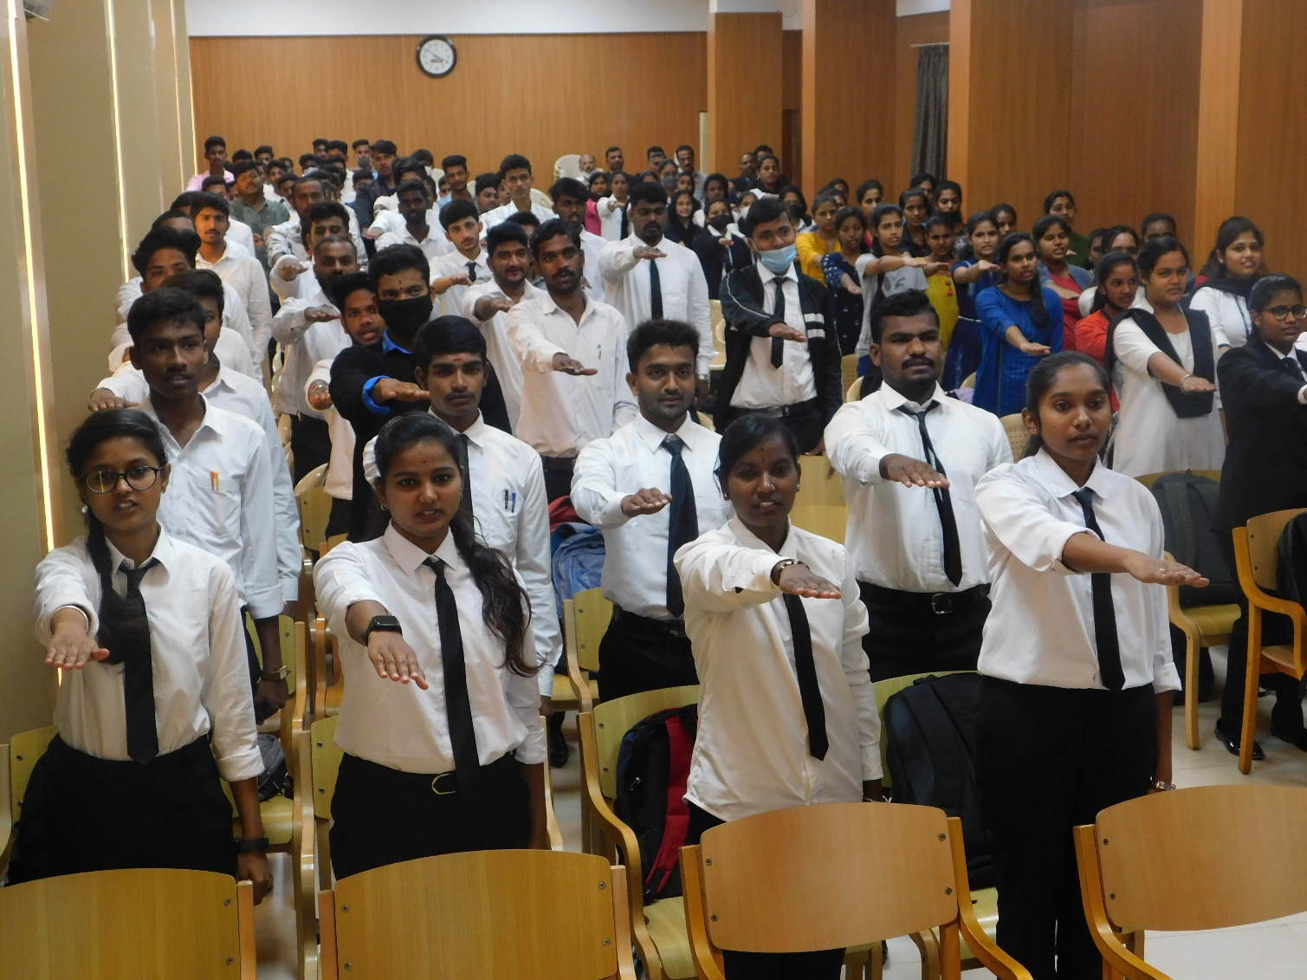

Dr. K.L.Chandrashekhara, Coordinator, Youth Red Cross Committee, VVLC, Mysuru concluded the programme through his vote of thanks.

Dr. K.L.CHANDRASHEKHARA

Programme Coordinator

Youth Red Cross Committee

Vidyavardhaka Law College

Mysuru -570001.

